Instructions for faxing from email client

To fax from your email, enter the fax number that you are sending to in the “To:” address field and attach your PDF document to the email. (You do not have to prefix the number with “8” or “Fax =”.)

Your “TO…” should look like this: [7708881126@fax.forsyth.k12.ga.us](mailto:7708881126@fax.forsyth.k12.ga.us)

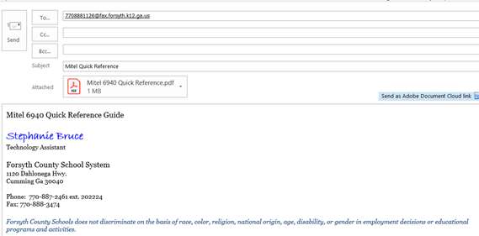

Once the fax has been sent, a fax job completion email will be sent to your inbox:  
  
